**NAAN MUDHAVAN**

**ASSIGNMENT DOCUMENT**

**COURSE TITLE** : DIGITAL MARKETING

**COLLEGE CODE** : 1105

**COLLEGE NAME** : GOJAN SCHOOL OF BUSINESS AND TECHNOLOGY

**NM ID** : E6B936AC895E69C8D7746E804E95C81E

**NAME** : RANJITH M

**REGISTER NUMBER** : 110520106331

**YEAR** : 4TH YEAR

**DEPARTMENT** : ELECTRONICS AND COMMUNICATION ENGINEERING

1. Create a blog or website using Blogspot and Wordpress. Customize the theme design and post new article with 500 words.

Link: BEST ELECTRICALS SALES AND SERVICES

<https://ranjithboy.blogspot.com/2023/10/best-electricals-sales-and-services.html>

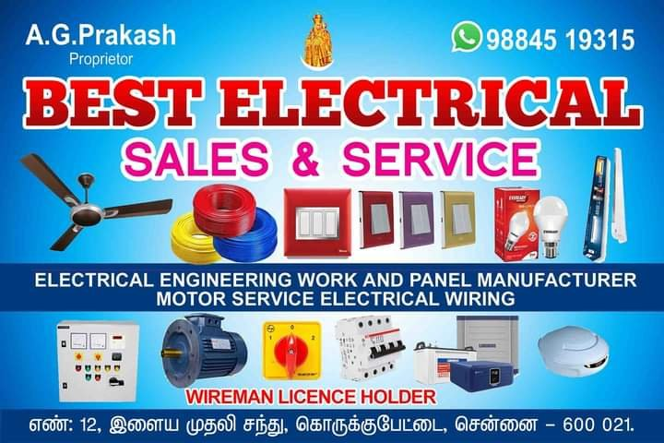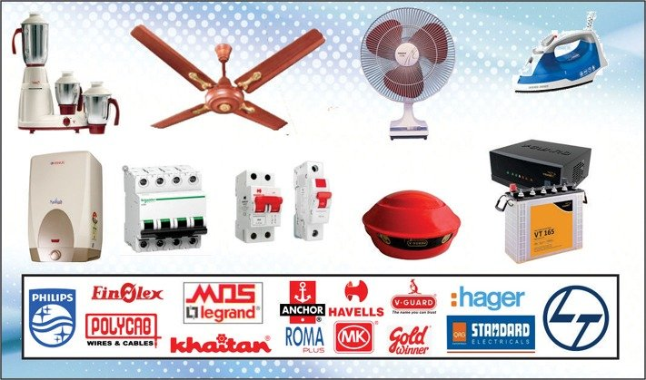

1. Create a New Facebook Business Page and post one social media poster for your brand.

Link:

<https://www.facebook.com/profile.php?id=61553111902213>

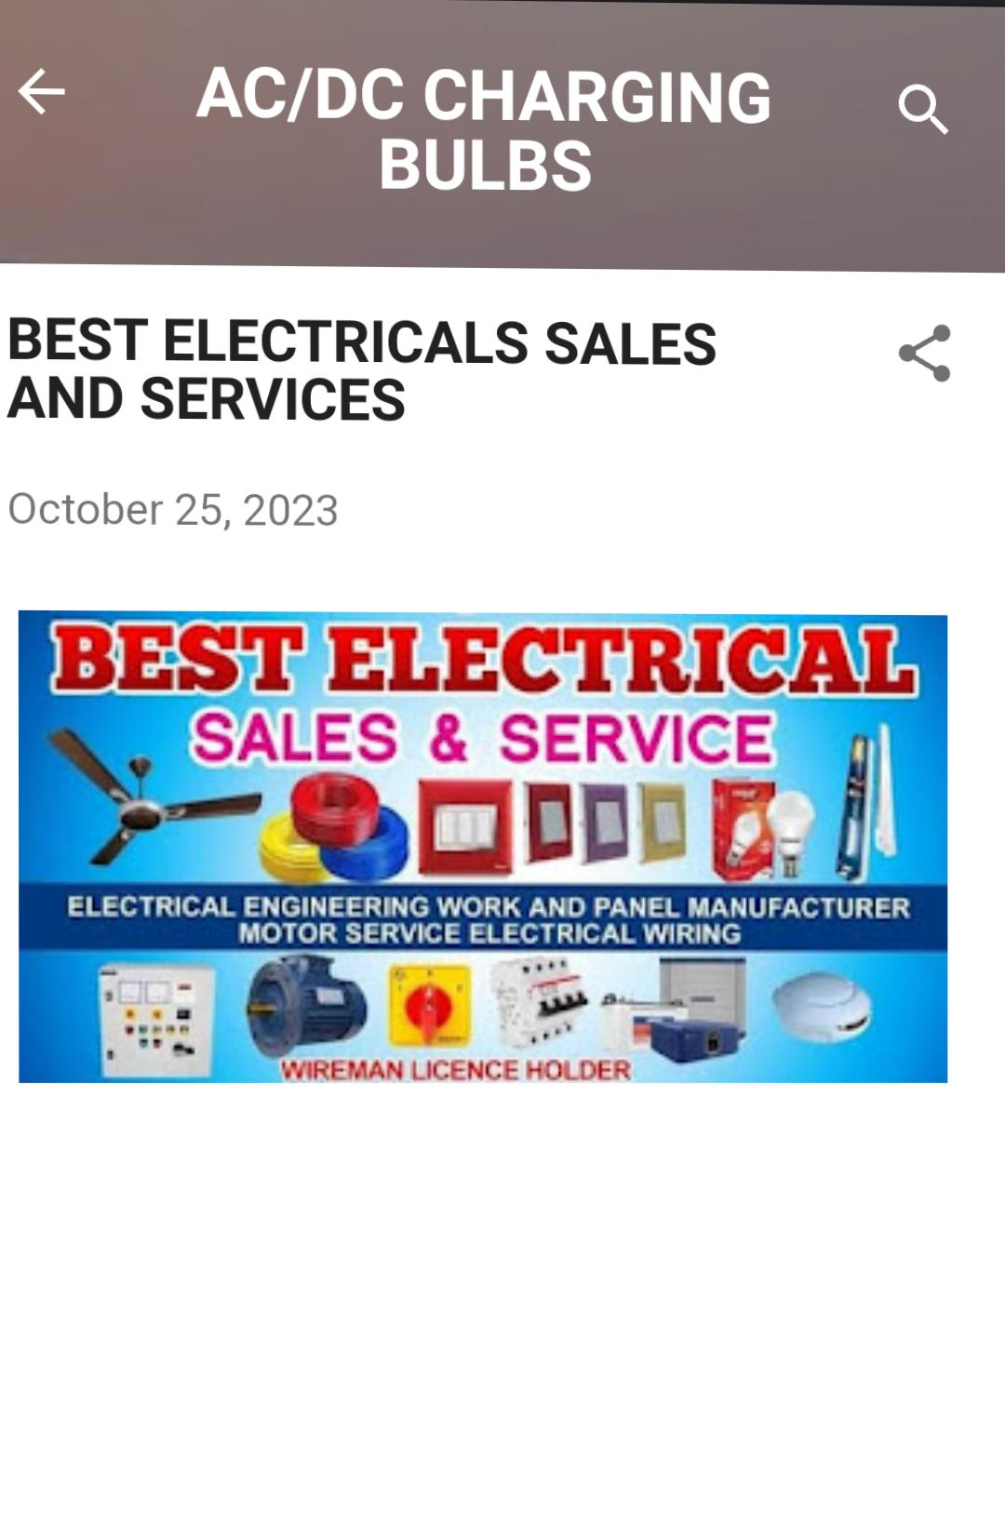

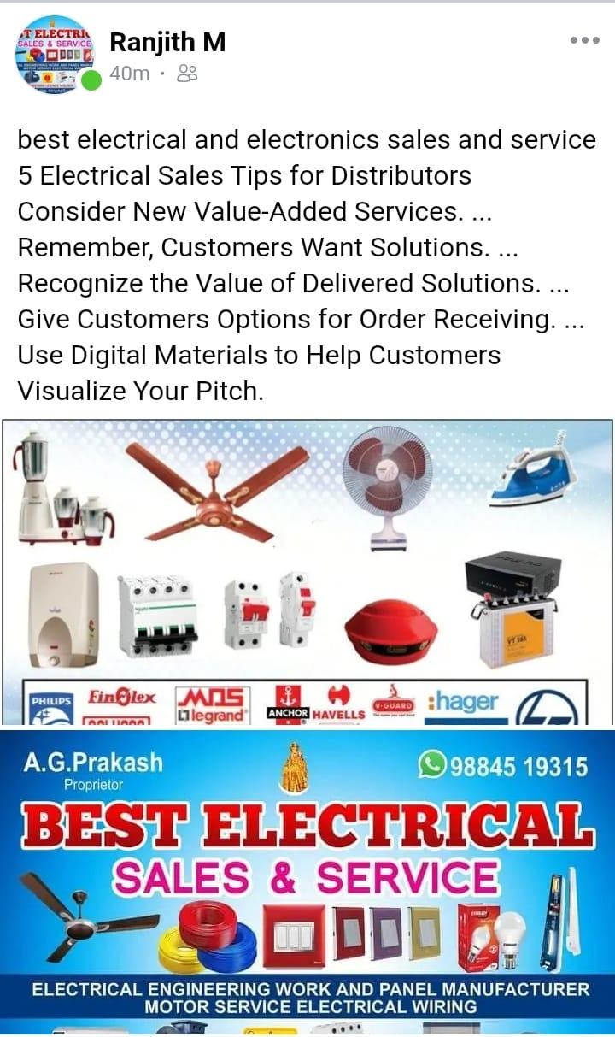

A great electrician website design.

Search engine optimization (SEO for electricians)

Content marketing.

PPC marketing for electricians.

Google Local Services ads.

Social media marketing for electricians (including Facebook ads for electricians)

Email marketing.

1. Create and design a social media advertisement poster using canva.



1. Create email newsletter design using MailChimp or canva tool.

Link: https: https://ranjithboy.blogspot.com/2023/10/best-electricals-sales-and-services.html

### **Industrial Panel Boards**

We do customize Panel Board

* Industrial panel boards
* Commercial panel boards
* Residential panel boards

### **Manual Transfer Switch**

We do assembly of Manual Transfer Switch Breaker type (MTS) regardless of amperes required

.Things To Consider While Choosing An Electrical Components Manufacturer

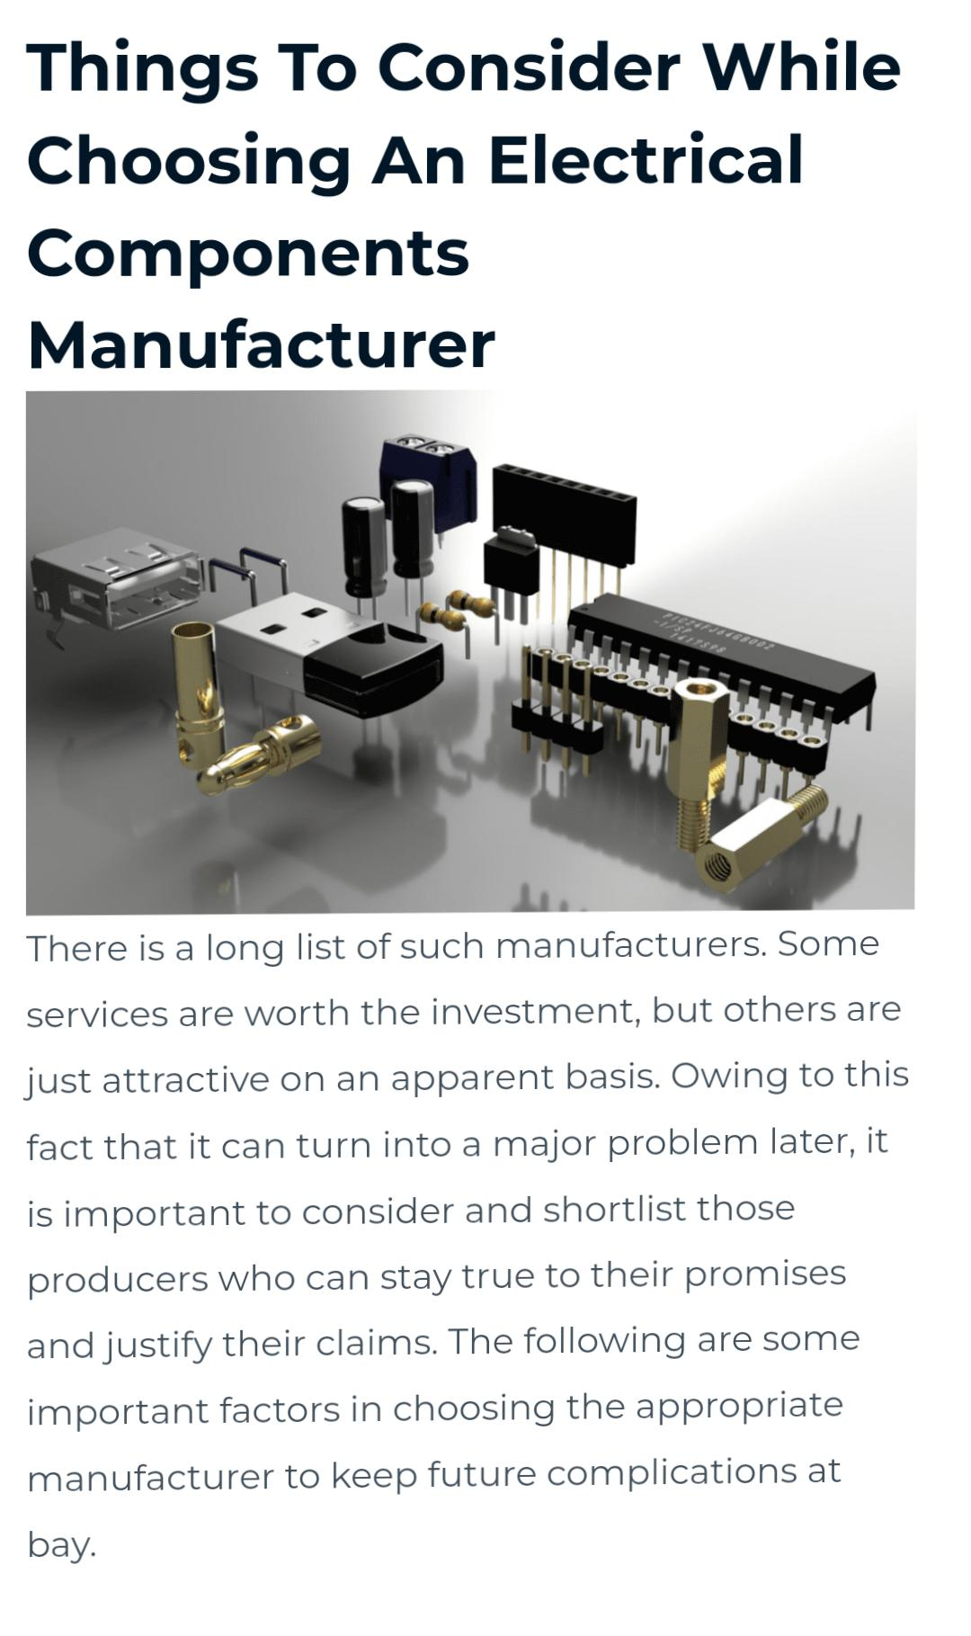



Rename your file as NM ID E6B936AC895E69C8D7746E804E95C81E -YOUR NAME

RANJITH M